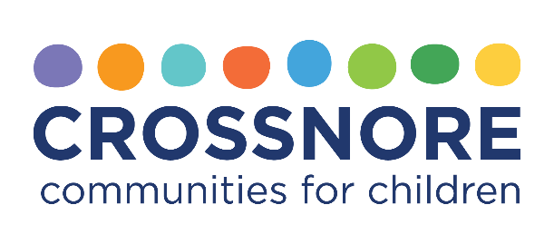

FOR IMMEDIATE RELEASE
News media contacts
Steve Bumgarner
Capture Public Relations & Marketing
336-722-9660, steve@capturevalue.com

Images available at crossnore.org/Hendersonville

Crossnore Communities for Children Announces $500,000 Matching Gift Challenge
Hendersonville, NC (September 19, 2024) — Crossnore Communities for Children is proud to announce renovation plans to a newly purchased property at 1410 Greenville Highway in Hendersonville.
Thanks to a generous $500,000 matching gift challenge from Flat Rock community members, Brian Robinson and Brendan Hill, Crossnore has the opportunity to nearly meet its $1.7 million goal to create a permanent and contemporary healing space to house our innovative programs, serving much of Western North Carolina.
Robinson and Hill are offering to match every dollar donated up to $500,000 between now and the end of October. This means that every contribution made towards the renovation project will be doubled, amplifying the impact of community support. In addition, the two have generously agreed to make an additional $500,000 gift towards the project if the challenge is met. In total, this matching gift opportunity will have a collective impact of up to $1.5 million to complete the project.
Robinson said, “Henderson County was given a rare gift in 2018 when Crossnore brought their nationally acclaimed work with at-risk youth to our community. Countless lives have been transformed in just six years. Now Crossnore wants to put down deeper, more permanent roots here. Brendan and I couldn't be more thrilled to help them achieve this goal. This new center will allow them to expand their work to fulfill the promise of home and hope to children in crisis.”

The property, a turn-of-the-century home on half an acre of commercial land, was acquired with the vision of providing a modern, collaborative environment for our growing staff and a welcoming space for our clients. The building requires extensive renovations to meet these needs.
To date, through Crossnore’s Promise of Home Campaign, the organization has raised $275,000 towards its $1.7 million project goal. Of this, $50,000 has been raised specifically toward the matching gift challenge. The renovation, managed by Dunlap Construction in Hendersonville, will establish a new, permanent home for Crossnore’s therapy, foster care, and family preservation services; external relations; and Crossnore’s Center for Trauma Resilient Communities.
“We are incredibly grateful for Brian Robinson and Brendan Hill’s extraordinary generosity,” said Brett Loftis, Crossnore CEO. “Brian's interest in and commitment to Crossnore’s work brought our programming to Hendersonville in 2018, and now he and Brendan are helping provide a permanent home for us in this community so our work can continue for years to come. We are very grateful for their friendship.”
To learn more about the project or how to donate toward the matching gift, visit crossnore.org/Hendersonville.
About Crossnore Communities for Children
For more than 100 years, Crossnore has been one of the most trusted names in child safety, protection, and welfare as a provider of holistic care, hope, and healing for children who have experienced trauma. Our promise to all children and families is to value and accept them wholly and to devote our exceptional resources to their needs. No organization is better positioned than Crossnore Communities for Children to give vulnerable families a broad-based ecosystem of support. For more information about Crossnore Communities for Children, please visit crossnore.org.

# # #

